The Main Street Price Index™
(MSPI™)

An Inflation Index for Main Street America
An Essentials-Based Measure of U.S. Consumer Prices, 1983–2026

Munir Moon
July 2026
MSPI™ and Main Street Price Index™ are trademarks pending.
Confidential

Disclaimer
This paper is provided for information and analysis. The Main Street Price Index is built entirely from public data published by the U.S. Bureau of Labor Statistics (BLS). It is independent and not affiliated with, endorsed by, or produced by any government agency. MSPI is a complement to the Consumer Price Index — not a replacement.
This document is confidential and intended for review only. © 2026 Munir Moon. All rights reserved. MSPI™ and Main Street Price Index™ are trademarks pending.

1. Introduction
One of the biggest worries households have today is the rising cost of living, and the worry is well founded. A basket of household essentials that sold for $100 in 1983 costs about $424 today; the official Consumer Price Index (CPI), the government's main inflation gauge, puts that same basket at about $331. Both come from the same government data. The difference is averaging: the CPI blends thousands of goods and services, from rent and groceries to airfare and electronics, which makes it a useful national number but hides a wide divergence from main street America’s reality.
The Main Street Price Index (MSPI) measures the household experience directly: it applies the Bureau of Labor Statistics' (BLS) own data and method, changing only the basket to keep the essentials a household cannot easily cut — shelter, food at home, medical care, utilities, work-related transportation, and connectivity. It also tracks the cumulative price level, not just the annual rate that can fall while prices keep climbing.
What follows shows how it is built, what four decades of official data reveal, and where its limits lie.

2. What MSPI Measures
MSPI includes the categories a household cannot easily cut. Three tests define an essential: the expense recurs, substitution is limited, and the category is a meaningful share of the budget. By those standards, MSPI contains six groups:
- Shelter — rent of primary residence, owners' equivalent rent, and tenants' insurance
- Food at home — groceries, not restaurant meals
- Medical care — insurance, services, and prescriptions
- Work-related transportation — motor fuel, vehicle insurance, and vehicle maintenance
- Utilities — household energy, water, sewer, and trash
- Connectivity — telephone and internet service
Together these account for about two-thirds of the CPI by weight. Dining out, airfare, hotels, new vehicles, electronics, clothing, and recreation are excluded — not because they are unimportant, but because they can be deferred or substituted in ways that shelter and medical care cannot. Connectivity is listed on its own rather than folded into utilities because the BLS tracks wireless and internet service as separate categories from household energy and water — and because their prices have behaved very differently, falling over the period while energy rose.

2.1 A Price Index, Not a Budget
MSPI tracks how fast prices change for a fixed basket. It makes no assumption about household size, income, or location. It is a price index — set directly beside the CPI because it uses the same data and method. Its single normative judgment is which categories qualify as essential, a line drawn from the common core of five established household-budget frameworks (Table 1). The MSPI weights in Table 1 are simply the CPI's own component weights rescaled to the essentials-only basket; Appendix A.6.2 works through that step in full, showing how shelter's 53.57 percent is derived.

Table 1. The MSPI Basket: CPI Weight vs. MSPI Weight
Component / Category | CPI Weight % | MSPI Weight %
ESSENTIAL — INCLUDED IN MSPI
SHELTER | 34.19 | 53.57
Rent of primary residence | 7.50 | 11.75
Owners' equivalent rent | 26.28 | 41.18
Tenants' & household insurance | 0.41 | 0.64
FOOD AT HOME | 8.04 | 12.60
MEDICAL CARE | 8.27 | 12.96
UTILITIES | 4.31 | 6.76
Household energy | 3.23 | 5.07
Water / sewer / trash | 1.08 | 1.69
TRANSPORTATION (work-related) | 6.80 | 10.65
Motor fuel | 2.98 | 4.67
Motor vehicle insurance | 2.80 | 4.38
Motor vehicle maintenance & repair | 1.02 | 1.60
CONNECTIVITY | 2.21 | 3.46
Wireless telephone service | 1.28 | 2.01

Table 1. The MSPI Basket: CPI Weight vs. MSPI Weight (continued)
Component / Category | CPI Weight % | MSPI Weight %
Internet services | 0.93 | 1.45
Essentials subtotal | 63.82 | 100.00
DISCRETIONARY — EXCLUDED
Food away from home (restaurants) | 5.41 | 0.00
New vehicles | 3.57 | 0.00
Apparel | 2.52 | 0.00
Airline fares & other transportation | 2.30 | 0.00
Used cars & trucks | 1.89 | 0.00
Lodging away from home | 1.36 | 0.00
Alcoholic beverages | 0.84 | 0.00
Tobacco & smoking products | 0.56 | 0.00
Recreation, education, furnishings, personal care & other¹ | 17.73 | 0.00
Discretionary subtotal | 36.18 | 0.00
ALL ITEMS (CPI) | 100.00 | 100.00
¹ Recreation, education, household furnishings and operations, personal care, and other goods and services.

3. Methodology
MSPI uses the same fixed-weight Laspeyres method the BLS uses for the CPI and its sub-indexes, such as Core CPI. The construction involves four steps: (1) select the essential categories; (2) take their official weights from the BLS relative-importance tables; (3) remove the rest; and (4) rescale the remaining weights so they sum to one (Appendix A). MSPI differs from the CPI for exactly one reason: the discretionary items are excluded.
Why start in 1983? The BLS adopted owners' equivalent rent — its current method for owner-occupied housing — in 1983. Starting in 1983 keeps the shelter component — the largest part of the basket — measured consistently throughout.

3.1 Data Sources
Every input is from official government sources. The CPI and each component come from the BLS as annual averages of monthly indexes. The weights are the BLS relative-importance figures for December 2024 — the most recent complete table at the time of construction (Appendix B). Fixing the basket at the latest vintage keeps MSPI transparent and reproducible.

4. Historical Findings
By 2026, on the MSPI, a $100 essentials basket from 1983 costs about $424. The CPI basket costs about $331. MSPI runs about 28 percent higher. The gap did not expand in any single recession year. It widened gradually and almost continuously across four decades — shelter and medical care grinding steadily above the CPI, partly offset in some years by volatile energy (Fig 1). Table 2 breaks the $100 basket into its components; Table 3 shows how fast each essential has risen.
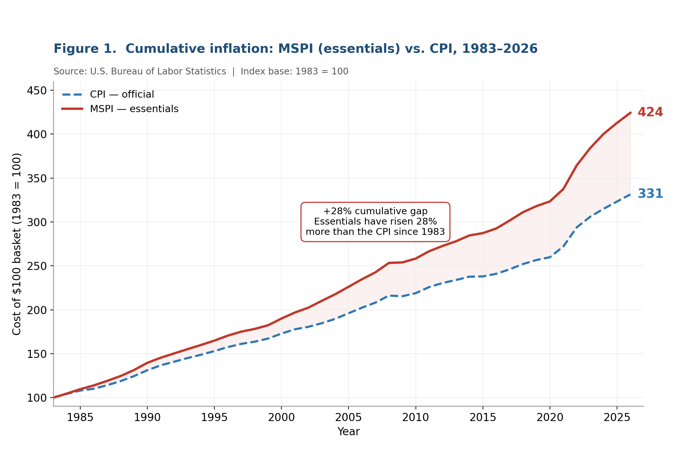
[Figure 1. Cumulative MSPI (424) versus CPI (331): a 28% gap has opened since 1983.]

Table 2. A $100 Essentials Basket and Its Components, 1983–2026
Essential | 1983 | 2026 | Change (nominal)
Shelter (OER + rent) | $54 | $226 | ~4.3×
Medical care | $13 | $75 | ~5.9×
Work-related transportation | $11 | $61 | led by vehicle insurance (~8.9×)
Food at home | $13 | $41 | ~3.2×
Utilities | $7 | $20 | ~2.9×
Connectivity | $2 | $1 | declined
TOTAL | $100 | ~$424

Table 3. Nominal Price Growth by Essential, 1983–2026
Essential | Price change | Share of basket | Note
Shelter (OER) | ~4.3× | Largest (41%) | Single biggest driver
Shelter (rent) | ~4.4× | 12% | Sets the housing floor
Medical care | ~5.9× | 13% | Service; resistant to efficiency gains
Vehicle insurance | ~8.9× | 4% | Steepest single component
Food at home | ~3.2× | 13% | Steady and broad-based
Household energy | ~2.9× | 5% | Volatile year to year
Motor fuel | ~3.3× | 5% | Volatile; ends above 1983
Connectivity | declined | 3% | The only essential that grew cheaper

5. Inflation Dynamics

5.1 Why Prices Rarely Fall
The cumulative level of inflation falls only in severe recessions — and even then, rarely for essentials. In 2009, at the depth of the financial crisis, the CPI turned negative (−0.36%) for the only time in recent history (Fig.2). Essential prices did not follow. MSPI stayed positive at +0.23%.
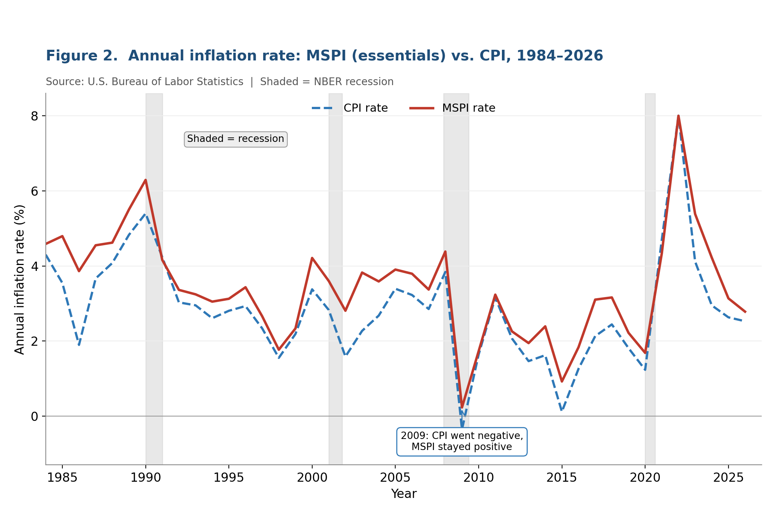

[Figure 2. Annual MSPI versus CPI rates with NBER recession bands, 1984–2026. Even in 2009, essential prices did not fall.]

5.2 Price Floors and the Long Climb
Every year, each essential either rises or holds. Connectivity is the rare exception. For shelter, medical care, food, energy, and transportation, the trajectory is upward. A recession may slow the rate, but it does not reset the base. Each year's price level becomes the floor for the next.

5.3 At the Federal Reserve's 2% Target
The Federal Reserve aims to keep inflation near 2 percent a year over the long run. Carried forward at that 2 percent pace from 2026 levels, by 2050 the CPI basket would cost about $533 and the MSPI basket about $682. The dollar gap between the MSPI and CPI baskets widens from about $93 today to about $149 by 2050 (Fig 3).
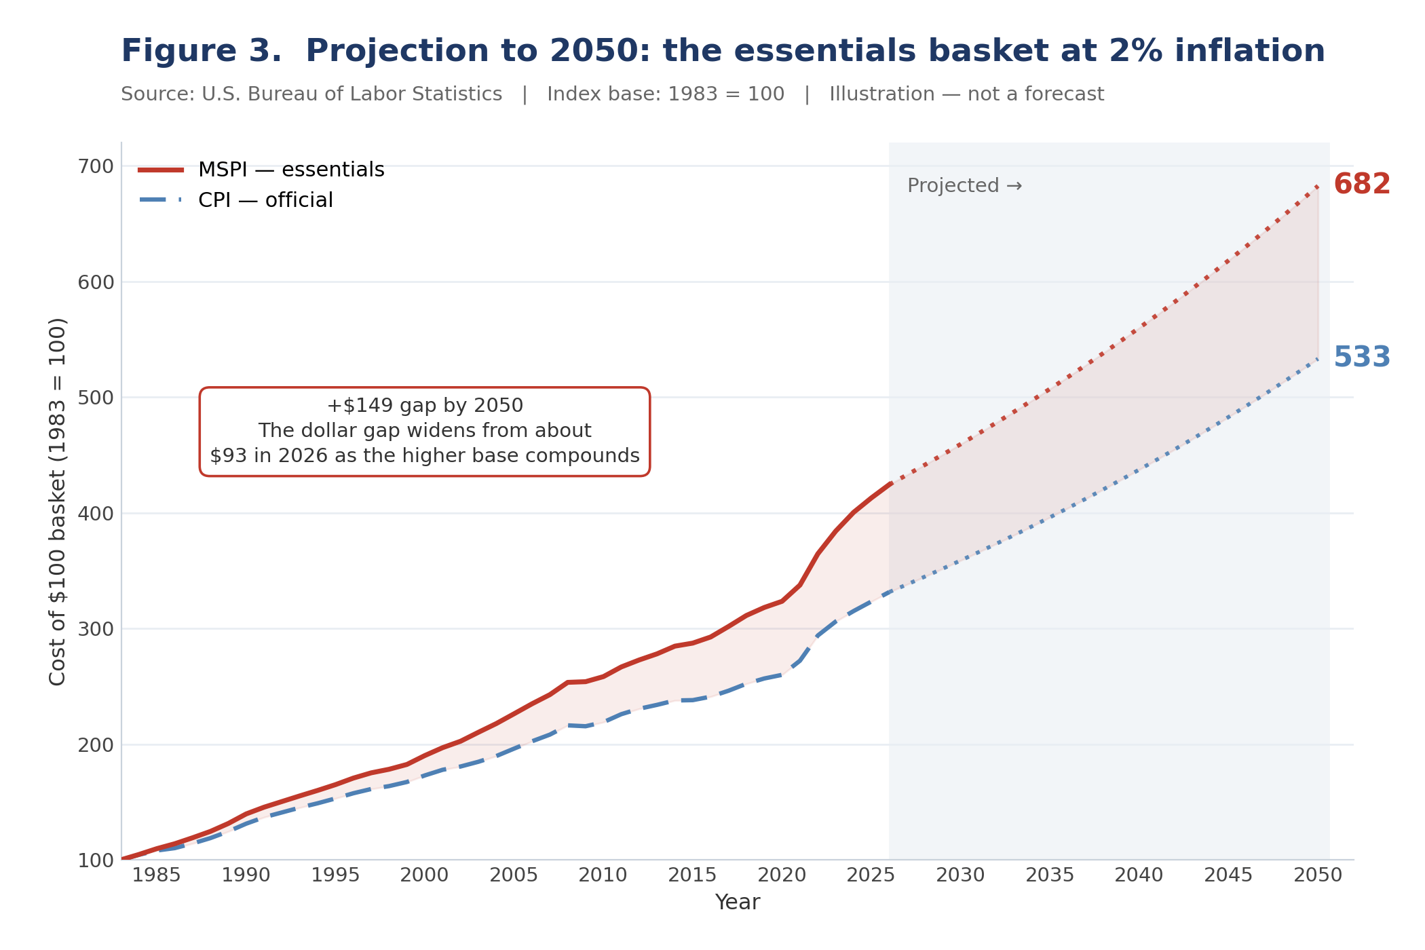

Figure 3. Projection to 2050: both series at 2%/yr from 2026. CPI → $533, MSPI → $682. Illustration only — not a forecast.
⚠ Projection Note — Illustration Only
Both MSPI and the CPI are projected at exactly 2.00%/yr from 2026 forward — consistent with the Fed's stated target and identical for both series. This is a scenario, not a forecast. The Fed's target is formally defined on the PCE deflator, which typically runs slightly below the CPI.

6. How MSPI Compares to Other Measures

6.1 Against the Standard Gauges
The essentials gap holds regardless of which benchmark it is set against. By 2026, the CPI sits near 331, Core CPI near 336, and the Cleveland Fed trimmed-mean near 332 — all clustered together. MSPI sits well above all three, near 424.
Core CPI removes food and energy to isolate the underlying policy trend. The trimmed-mean discards the most extreme monthly moves. MSPI takes a different approach — it removes discretionary categories to expose the household floor. That floor sits roughly 26 to 28 percent higher than any of the three standard benchmarks.

6.2 Against Other Essential-Focused Measures
Several other measures look past the headline at essentials (Table 4). None offers a simple cumulative inflation index built entirely from official BLS data and the BLS's own method.

Table 4. MSPI Among Essential-Focused Measures
Measure | Type | Basket | Reproducible from public data
Main Street Price Index | Price index | Essentials only | Yes — BLS data, open method
LISEP True Living Cost | Dollar budget | Essentials, incl. childcare | Partly
LISEP Minimal Quality of Life | Dollar budget | Essentials plus modest extras | Partly
ALICE Essentials Index | Cost index | Survival basket, incl. childcare | Partly (by state)
Strategas Common Man CPI | Price index | Essential subset | No — proprietary
AIER Everyday Price Index | Price index | Frequently bought items | Partly

7. Policy Implications

7.1 What MSPI Shows and What It Does Not Claim
MSPI shows that essential prices have risen materially faster than the CPI over four decades and quantifies that margin from official data. It does not claim that the CPI is mismeasured. It does not claim that any specific household's costs have risen by the index amount. It reflects the cumulative price change of a defined basket.

7.2 Where MSPI Can Be Applied
For policymakers: Wage standards, benefit adjustments, and eligibility thresholds indexed to the CPI may systematically understate cost pressures on households concentrated in essentials. Concretely: a benefit worth $1,000 a month in 1983, adjusted each year by the CPI, would be about $3,310 today; adjusted by the MSPI — which tracks the essentials the benefit is meant to cover — it would be about $4,240. The CPI-indexed benefit falls roughly $930 a month, or 28 percent, short of the essentials it was designed to fund. The same gap applies to any wage floor or eligibility threshold tied to the CPI.
For researchers: The open-data construction makes MSPI a clean, reproducible baseline. Because it uses the same method as the CPI, any difference is attributable entirely to basket composition — not to methodology, data source, or estimation assumptions.
For journalists and the public: MSPI restates the inflation question in terms households actually face: not "what was the average price change across all spending?" but "how much more do my essential bills cost than they did a decade ago?"

8. Regional and Demographic Extensions

8.1 Why These Versions Matter
National averages mask significant local and demographic variation. The same basket that defines national MSPI can be produced for a specific metro area or demographic group using the same official data and method. Wages, benefits, and eligibility thresholds are often indexed to a broad average that understates cost pressure on specific places or populations.

8.2 Planned Variants
Note: The variants described below are planned extensions. None has been computed in this version of the paper. Each is a natural next step once the relevant BLS regional or demographic series are assembled.
- Metropolitan areas. Los Angeles is the natural first regional case; its structurally high housing costs would make the essential gap especially visible. New York, Miami, and Houston diverge from the national average as sharply, for varied reasons.
- Demographic groups. A seniors' MSPI would weight medical care far more heavily. Indexes for lowest-income households, Gen Z renters, or retirees would each re-weight the basket to match how those groups actually spend.
- Each variant answers the same question for a specific place or population: how fast are essential costs rising for these households? Because all would rest on the same official data and method, they would be directly comparable to the national index.

9. Limitations and Caveats
- The essential-category line is a judgment. The essential-versus-discretionary boundary is drawn from five established household-budget frameworks. Other analysts could draw it differently without materially changing the main findings.
- Fixed weights. MSPI holds each essential's share fixed at its December 2024 level. Letting shares change year by year would shift cumulative totals modestly but not change the basic findings.
- National average. MSPI measures national price change. A specific household's experience will diverge in both directions.
- Inherited conventions. MSPI uses BLS price series as published, including owners' equivalent rent and the CPI's treatment of medical care. This keeps it simple and fully reproducible.
- 2026 data is partial-year. The 2026 figures use January–May data only. Full-year averages may differ modestly.

10. Conclusion
The CPI is a well-built measure of a broad question. MSPI answers a narrower one from the same data: the essential price index for Main Street America.
Strip out the optional purchases and track what a household cannot avoid since 1983. A steeper climb appears — 28 percent steeper than the official index.
The number that matters most is not the annual rate. It is the cumulative level. An essentials basket that cost $100 in 1983 costs $424 today. The full CPI basket costs $331. At the Federal Reserve's own 2 percent target, both will keep rising — and the dollar gap will keep widening.
That distance between the headline and the household ledger is what MSPI measures. For the family whose income is mostly essentials, the cost of living is not an average. It is shelter, food, medical care, and the means of getting to work. MSPI measures exactly that — in the open, from public data, in a form any analyst can verify.

Appendix A. MSPI Methodology

A.1 Purpose and Scope
This appendix is the canonical technical specification for MSPI. It covers data sources, the essential/discretionary boundary, the renormalization and aggregation mathematics, the weighting scheme, and the rules required to reproduce the series exactly. An independent analyst using this appendix and public BLS data should arrive at identical numbers.
MSPI is a diagnostic re-aggregation of official BLS CPI components. It is not a correction of the CPI and makes no claim of mismeasured inflation. Every price input is a published BLS series used verbatim.

A.2 What MSPI Measures
MSPI tracks the essential household costs that cannot be avoided — shelter, groceries, healthcare, commuting, utilities, and connectivity. It is the CPI with discretionary categories removed, then re-aggregated the way the BLS builds its own special aggregates. MSPI is the structural inverse of Core CPI: Core removes food and energy to isolate the policy trend; MSPI removes the optional to isolate the household floor.

A.3 Data Sources
- Essential component price indexes, CPI all items, and Core CPI. U.S. Bureau of Labor Statistics, Consumer Price Index, U.S. city average, not seasonally adjusted, as annual averages of monthly indexes. Series identifiers are in A.5.
- Component weights. BLS Relative Importance of Components, U.S. city average, December 2024.
- Base-period transformation. BLS publishes most CPI series on a 1982–1984 = 100 base. MSPI re-indexes all levels to 1983 = 100 so MSPI, CPI, and Core CPI share a common starting point.

A.4 Category Boundary: Essential vs. Discretionary
The essential/discretionary line comes from published frameworks rather than our own judgment. The essentials set is the common core of five authoritative cost-of-living frameworks: the IRS Collection Financial Standards, the EPI Family Budget Calculator, the MIT Living Wage Calculator, United Way's ALICE Household Survival Budget, and the Self-Sufficiency Standard. All five treat as essential: housing, food, utilities, healthcare, and transportation. Connectivity is added under a universal, non-substitutable monthly-outlay criterion.
The excluded residual is about 36% of CPI weight and is heterogeneous — some genuinely optional (recreation, luxury apparel, dining out, alcohol, tobacco), some excluded for methodological reasons (vehicle purchases, education). The boundary is a defensible normative choice, not an official classification.

A.5 Component Basket and BLS Series Identifiers
Component | BLS Series ID | Group | RI % of CPI | Core wt % | Full wt %
Rent of primary residence | CUUR0000SEHA | Shelter | 7.499 | 12.472 | 11.749
Owners' equivalent rent | CUUR0000SEHC | Shelter | 26.282 | 43.710 | 41.179
Tenants' & household insurance | CUUR0000SEHD | Shelter | 0.410 | 0.000 | 0.642
Food at home | CUUR0000SAF11 | Food | 8.043 | 13.376 | 12.602
Medical care | CUUR0000SAM | Medical care | 8.273 | 13.759 | 12.962
Household energy | CUUR0000SAH21 | Utilities | 3.233 | 5.377 | 5.065
Water/sewer/trash | CUUR0000SEHG | Utilities | 1.079 | 0.000 | 1.691
Motor fuel | CUUR0000SETB | Transportation | 2.983 | 4.961 | 4.674
Motor vehicle insurance | CUUR0000SETE | Transportation | 2.796 | 4.650 | 4.381
Motor vehicle maint. & repair | CUUR0000SETD | Transportation | 1.019 | 1.695 | 1.597
Wireless telephone service | CUUR0000SEED03 | Connectivity | 1.281 | 0.000 | 2.007
Internet services | CUUR0000SEEE03 | Connectivity | 0.926 | 0.000 | 1.451
Essentials total |  |  | 63.824 | 100.000 | 100.000
RI % of CPI is the component's relative-importance weight within the full CPI. Core wt % is its weight in the eight-component Core basket (used for 1983–1998); Full wt % is its weight in the twelve-component Full basket (used from 1999 onward). Within each basket the kept weights are renormalized to sum to 100.

A.6 The Mathematical Engine
MSPI applies the BLS special-aggregate construction in three steps.
- Step 1 — Renormalize kept weights to sum to one: wᵢ = RIᵢ / Σⱼ RIⱼ
- Step 2 — Aggregate into a fixed-basket (Laspeyres) level: Iₜ = 100 × Σᵢ wᵢ (Pᵢ,ₜ / Pᵢ,₀)
- Step 3 — Differentiate the level into an inflation rate: πₜ = (Iₜ / Iₜ₋₁) − 1
where:
i, j — index over the essential (kept) components; the summations run over all kept components
RIᵢ — BLS relative-importance weight of component i (December 2024)
wᵢ — renormalized weight of component i (kept weights rescaled to sum to 1)
Pᵢ,₀ — price index of component i in the base year (1983)
Pᵢ,ₜ — price index of component i in year t
Iₜ — MSPI index level in year t (1983 = 100)
πₜ — MSPI inflation rate in year t (year over year)
Renormalization does not inflate the result. Scaling every kept weight by the same constant leaves their weighted average unchanged. MSPI differs from the CPI for exactly one reason: discretionary components are excluded.

A.6.1 Worked Example: One Essential, Then All Six
Take groceries (food at home) through Step 2 for 2026:
Symbol | What it is | Number
Pᵢ,₀ | Grocery price index, 1983 | 99.1
Pᵢ,ₜ | Grocery price index, 2026 | 319.4
Pᵢ,ₜ / Pᵢ,₀ | How many times the price grew | 3.2×
wᵢ | Groceries' share of the basket | 0.126
wᵢ × (Pᵢ,ₜ / Pᵢ,₀) | Groceries' piece of the index | 0.41

On the ×100 scale, groceries contribute about $41 of the $100 basket, up from $13 in 1983. Repeating this for all six essentials and summing:
Each term in that sum is one essential group's renormalized weight (wᵢ) multiplied by how many times its price grew between 1983 and 2026 (Pᵢ,ₜ / Pᵢ,₀):
Shelter: 0.536 × 4.2 ≈ 2.26
Medical care: 0.130 × 5.8 ≈ 0.75
Work-related transportation: 0.107 × 5.7 ≈ 0.61
Food at home: 0.126 × 3.2 ≈ 0.41
Utilities: 0.068 × 2.9 ≈ 0.20
Connectivity: 0.035 × 0.3 ≈ 0.01
MSPI₂₀₂₆ = 100 × (2.26 + 0.75 + 0.61 + 0.41 + 0.20 + 0.01) = 100 × 4.24 ≈ 424
Each of the six figures is simply that group's weight times its price growth. Shelter dominates because it is both the largest weight and a fast riser; connectivity is near zero because its price fell. Summed and scaled by 100, the six terms reproduce the 424 that the full chained series produces.

A.6.2 Worked Example: How the Shelter Weight Is Set
MSPI does not invent weights. Each one is the CPI’s own published relative importance (RI), taken from the BLS December 2024 relative-importance table (Appendix A.5) and rescaled so the six kept essentials sum to 100 percent (Step 1 in A.6). For any component i, the renormalized weight is:
wᵢ = RIᵢ / Σⱼ RIⱼ
Symbol | What it is | Number
RIᵢ | Shelter’s relative importance in the full CPI (i = shelter) | 34.19
Σⱼ RIⱼ | CPI relative importance of all six kept essentials, summed | 63.82
wᵢ | Shelter’s renormalized MSPI weight (the result) | 53.57%
Both inputs come straight from the BLS relative-importance table. The numerator is the component’s own CPI weight; the denominator is the sum of the six kept essentials’ CPI weights. Each breaks down as follows.
The numerator, RIᵢ, is shelter’s CPI weight — itself the sum of its three parts:
RIᵢ = 26.28 (owners’ equivalent rent) + 7.50 (rent) + 0.41 (tenants’ and household insurance) = 34.19
The denominator, Σⱼ RIⱼ, adds up the CPI weight of all six essential groups:
Shelter: 34.19
Medical care: 8.27
Food at home: 8.04
Work-related transportation: 6.80
Utilities: 4.31
Connectivity: 2.21
Total: 63.82
Dividing the two gives shelter’s MSPI weight:
wᵢ = 34.19 / 63.82 = 0.5357 ≈ 53.57%
The same division sets every other MSPI weight in Table 1 — rent 7.50 / 63.82 = 11.75 percent, owners’ equivalent rent 26.28 / 63.82 = 41.18 percent — and the three shelter pieces add back to 53.57 percent.

A.7 Weighting Methodology
Every component's weight comes from the BLS's December 2024 relative-importance table — the same table the BLS uses to build the CPI. Because MSPI drops the discretionary categories, the kept weights are rescaled so they add up to 100 percent (Step 1 in A.6), and then held fixed for every year in the series, so that year-to-year movement in the index reflects prices rather than a shifting basket. The index uses two baskets over time: an eight-component Core basket for 1983–1998, and a fuller twelve-component basket from 1999 onward, once the BLS began publishing series for connectivity, water/sewer/trash, and tenants' insurance.

A.8 Construction and Series Notes
- Series begins in 1983 — the year the BLS began measuring owner-occupied shelter through owners' equivalent rent. Earlier data used a discontinued method.
- Connectivity, water/sewer/trash, and tenants' insurance first appear in BLS data in late 1997 and enter the annual index in 1999. The basket covers ~60% of CPI before 1999 and ~64% after.
- All component series are U.S. city average, not seasonally adjusted, taken as annual averages of monthly indexes.
- Levels are aligned to 1983 = 100 for CPI, Core CPI, and MSPI so the divergence reads directly off the index levels.

A.9 Reproducibility
- Zero synthetic data. Every value derives from certified BLS or FRED series.
- Proportional weight preservation. Renormalization rescales all essential weights by a single common denominator, preserving every internal ratio.
- Adherence to BLS sub-indexing. Construction mirrors the special-aggregate method in Chapter 17 of the BLS Handbook of Methods — the same procedure used to build Core CPI.
- Full scriptability. The series can be regenerated from published BLS series IDs and a public weight table, using a free BLS API key and FRED's open endpoints.

A.10 Caveats a Reviewer Will Raise
- Fixed weights. The basket uses December 2024 relative importance throughout; weights updated period by period would shift the cumulative figure modestly.
- Bases and averaging. CPI, Core, and MSPI use annual-average levels aligned to 1983 = 100.
- Inherited methodology. MSPI re-aggregates official CPI components and inherits their methodology, including hedonic quality adjustment.
- A normative boundary. The essential/discretionary line is a sourced but normative choice. There can be no single official version of an essentials index.

A.11 References
- U.S. Bureau of Labor Statistics. Consumer Price Index, U.S. city average, not seasonally adjusted (CPI-U, Core CPI, and component series in A.5). https://www.bls.gov/cpi/
- U.S. Bureau of Labor Statistics. Relative Importance of Components, December 2024. https://www.bls.gov/cpi/tables/relative-importance/home.htm
- U.S. Bureau of Labor Statistics. Handbook of Methods, Chapter 17 (Consumer Price Index). https://www.bls.gov/opub/hom/cpi/
- IRS Collection Financial Standards. https://www.irs.gov/businesses/small-businesses-self-employed/collection-financial-standards
- EPI Family Budget Calculator. https://www.epi.org/resources/budget/
- MIT Living Wage Calculator. https://livingwage.mit.edu/
- United Way ALICE Household Survival Budget. https://www.unitedforalice.org
- Self-Sufficiency Standard. https://selfsufficiencystandard.org/
- Jaravel, X. "Inflation Inequality: Measurement, Causes, and Policy Implications." Annual Review of Economics, Vol. 13, 2021.

Appendix B. Year-by-Year Series, 1983–2026
Annual rates and cumulative index levels. 2026 reflects partial-year (January–May) data only.
Year | CPI % | Core % | MSPI % | MSPI−CPI (pp) | CPI Level | MSPI Level
1983 | — | — | — | — | 100.0 | 100.0
1984 | 4.3 | 4.9 | 4.6 | +0.29 | 104.3 | 104.6
1985 | 3.5 | 4.4 | 4.8 | +1.25 | 108.0 | 109.6
1986 | 1.9 | 4.0 | 3.9 | +1.96 | 110.0 | 113.8
1987 | 3.7 | 4.1 | 4.5 | +0.88 | 114.1 | 119.0
1988 | 4.1 | 4.4 | 4.6 | +0.54 | 118.7 | 124.5
1989 | 4.8 | 4.5 | 5.5 | +0.68 | 124.5 | 131.4
1990 | 5.4 | 5.0 | 6.3 | +0.89 | 131.2 | 139.6
1991 | 4.2 | 4.9 | 4.2 | −0.08 | 136.7 | 145.4
1992 | 3.0 | 3.7 | 3.4 | +0.33 | 140.9 | 150.3
1993 | 3.0 | 3.3 | 3.2 | +0.29 | 145.0 | 155.2
1994 | 2.6 | 2.9 | 3.0 | +0.44 | 148.8 | 159.9
1995 | 2.8 | 3.0 | 3.1 | +0.32 | 153.0 | 164.9
1996 | 2.9 | 2.7 | 3.4 | +0.50 | 157.5 | 170.6
1997 | 2.3 | 2.4 | 2.7 | +0.32 | 161.2 | 175.1
1998 | 1.6 | 2.3 | 1.8 | +0.22 | 163.7 | 178.2
1999 | 2.2 | 2.1 | 2.3 | +0.15 | 167.2 | 182.4
2000 | 3.4 | 2.4 | 4.2 | +0.83 | 172.9 | 190.1
2001 | 2.8 | 2.7 | 3.6 | +0.77 | 177.8 | 196.9
2002 | 1.6 | 2.3 | 2.8 | +1.22 | 180.6 | 202.4
2003 | 2.3 | 1.5 | 3.8 | +1.55 | 184.7 | 210.2
2004 | 2.7 | 1.8 | 3.6 | +0.91 | 189.6 | 217.7
2005 | 3.4 | 2.2 | 3.9 | +0.51 | 196.0 | 226.2
2006 | 3.2 | 2.5 | 3.8 | +0.57 | 202.3 | 234.8
2007 | 2.9 | 2.4 | 3.4 | +0.52 | 208.1 | 243.0
2008 | 3.8 | 2.3 | 4.4 | +0.54 | 215.9 | 253.7
2009 | −0.4 | 1.7 | +0.2 | +0.59 | 215.1 | 254.3
2010 | 1.6 | 1.0 | 1.7 | +0.09 | 218.6 | 258.7
2011 | 3.2 | 1.7 | 3.2 | +0.08 | 225.6 | 267.1
2012 | 2.1 | 2.1 | 2.3 | +0.19 | 230.3 | 273.2
2013 | 1.5 | 1.7 | 1.9 | +0.48 | 233.8 | 278.4
2014 | 1.6 | 1.7 | 2.4 | +0.77 | 237.6 | 285.1
2015 | 0.1 | 2.0 | 0.9 | +0.80 | 237.8 | 287.7
2016 | 1.3 | 2.2 | 1.8 | +0.57 | 240.8 | 292.9
2017 | 2.1 | 1.8 | 3.1 | +0.97 | 246.0 | 302.0
2018 | 2.4 | 2.1 | 3.2 | +0.72 | 251.8 | 311.6
2019 | 1.8 | 2.3 | 2.2 | +0.41 | 256.4 | 318.4
2020 | 1.2 | 1.7 | 1.7 | +0.45 | 259.5 | 323.8
2021 | 4.7 | 3.6 | 4.3 | −0.36 | 271.7 | 337.7
2022 | 8.0 | 6.2 | 8.0 | 0.00 | 293.5 | 364.8
2023 | 4.1 | 4.8 | 5.4 | +1.27 | 305.6 | 384.5
2024 | 3.0 | 3.3 | 4.2 | +1.27 | 314.7 | 400.7
2025 | 2.6 | 3.3 | 3.1 | +0.50 | 322.9 | 413.3
2026* | 2.5 | 3.0 | 2.8 | +0.26 | 331.4 | 424.3
* January–May 2026 data only.

Appendix C. Projections to 2050 at the Fed’s 2% Target
This projection carries both baskets forward from their 2026 levels at 2 percent a year — the Federal Reserve's long-run inflation goal — as an illustration, not a forecast. By 2050 the CPI basket reaches about 533 and the MSPI basket about 682 (1983 = 100). The dollar gap widens from about $93 in 2026 to about $149 by 2050 even though both series are assumed to rise at the same 2 percent rate. This is the compounding effect of a higher starting level, not a faster rate.
Year | CPI level | MSPI level | Dollar gap (MSPI − CPI)
2026 | 331.4 | 424.3 | $93
2027 | 338.0 | 432.8 | $95
2028 | 344.8 | 441.5 | $97
2029 | 351.7 | 450.3 | $99
2030 | 358.7 | 459.3 | $101
2031 | 365.9 | 468.5 | $103
2032 | 373.2 | 477.8 | $105
2033 | 380.7 | 487.4 | $107
2034 | 388.3 | 497.1 | $109
2035 | 396.1 | 507.1 | $111
2036 | 404.0 | 517.2 | $113
2037 | 412.1 | 527.6 | $116
2038 | 420.3 | 538.1 | $118
2039 | 428.7 | 548.9 | $120
2040 | 437.3 | 559.9 | $123
2041 | 446.0 | 571.1 | $125
2042 | 454.9 | 582.5 | $128
2043 | 464.0 | 594.1 | $130
2044 | 473.3 | 606.0 | $133
2045 | 482.8 | 618.1 | $135
2046 | 492.4 | 630.5 | $138
2047 | 502.3 | 643.1 | $141
2048 | 512.3 | 656.0 | $144
2049 | 522.6 | 669.1 | $147
2050 | 533.0 | 682.5 | $149

The Main Street Price Index™ is an independent analysis built from public data.
Not affiliated with, endorsed by, or produced in partnership with the BLS or any government agency.
© 2026 Munir Moon. All rights reserved.

